Problem Statement

The goal of this analysis is to perform unsupervised clustering on the Dry Bean Dataset using KMeans to uncover natural groupings of bean types based on morphological features. The dataset contains continuous numerical attributes such as area, perimeter, eccentricity, and compactness, describing the physical structure of seven bean types. These labels are used only for evaluation, not training.

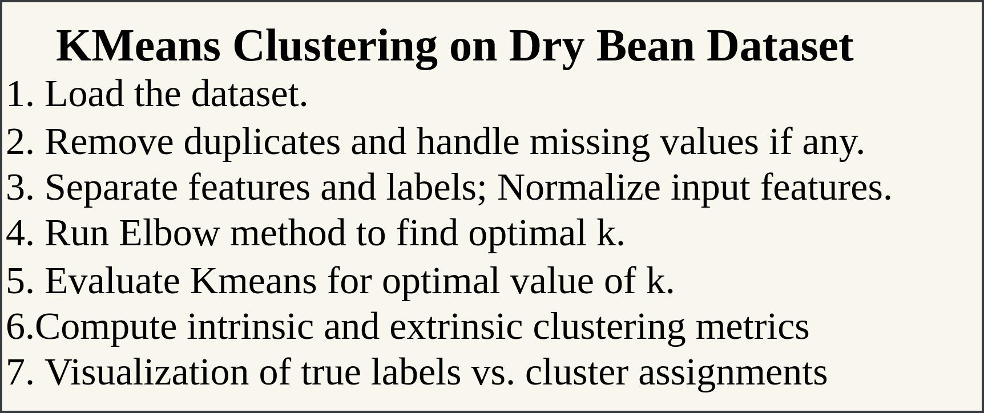

KMeans Clustering
Dataset: Dry Bean Dataset
Filename: Dry_Bean_Dataset.xlsx
About: Contains shape and morphological measurements for seven types of dry beans, extracted from digital images.
Task: Group beans into clusters based on physical features (unsupervised learning).

Workflow:
- Preprocessing: Load the Dry Bean dataset, check for missing values or duplicates, and encode class labels numerically.
- Data Preparation: Extract numerical features and normalize them to bring all features onto the same scale.
- Modeling: Apply KMeans clustering with different values of k to identify underlying structure in the data.
- Model Selection: Use the Elbow Method to estimate a suitable number of clusters based on inertia values.
- Evaluation: Assess clustering quality using intrinsic metrics (Silhouette Score, Calinski-Harabasz Index, Davies-Bouldin Score) and extrinsic metrics (Rand Index, Homogeneity, Completeness, Adjusted Rand Index, Adjusted Mutual Information).
- Visualization: Use t-SNE projection to visually compare true class labels and predicted cluster assignments.
- Comparison: Repeat the above steps for k = 6 and k = 8, and compare the results to analyze the impact of changing the number of clusters.

